**Echo Squad Solution Suite: Chinook Music Store Application Development progress**

**Introduction**

This document has been updated to provide a detailed overview of Echo Squad's efforts in developing the Chinook Music Store Application, a key component of the Team Echo Solution Suite. Following a strategic realignment and team restructuring, our strategy leverages the unique strengths of each member to meet our Capstone course objectives. I'm excited to share progress on the Chinook Music Store Application, where I've focused on utilizing the Entity Framework for database connectivity to the Chinook SQL Server. Currently, the application has a static UI with a homepage, menus, and buttons but lacks active data linkage. This stage allows us to preview the layout and design, although it's not yet functional with dynamic content. Key menus include 'Exit' and 'Pages' for navigation, but features like 'View All Artists', 'View All Albums', and 'View All Tracks' are inactive due to the pending database connection. My goal is to connect these UI elements to the database for dynamic content display, emphasizing visual appeal and usability.

Additionally, we've confirmed the successful implementation of all functionalities from the previous milestone. We've enhanced search capabilities on Artist, Album, and Track pages with dynamic filtering via LINQ queries. A new Music Catalog page, part of the navigation, offers a databound GUI that organizes data by artist name initials with collapsible groups. The Customer Orders page displays detailed customer and invoice information with a databound GUI. We've maintained a clean project structure and applied resource-defined styling to improve the UI and user experience.

**Instructor Approval and Guidance**

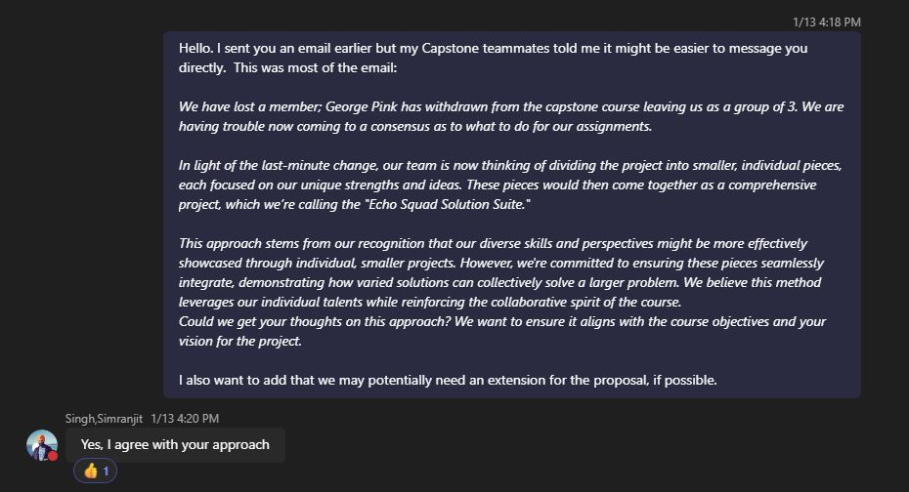

* **Direct Communication with Instructor**: Our revised approach, including a proposal extension request, was communicated, and endorsed by our instructor, Simranjit Singh.

**Continuous Team Coordination**

* **Weekly Reports**: Emphasized the importance of regular individual report submissions for consistent progress tracking and accountability.
* **Learning Contract Submission**: Adherence to the prescribed template for the learning contract proposal.

**Project Development**

**Application Overview**

* **Current State**: The Chinook application is currently in a stage where the user interface is static.
* **Objective**: The Entity Framework for database connectivity with the Chinook SQL Server database has been implemented,
* **Menus and Pages**: The application includes features such as 'Exit', 'Pages', and options like 'View All Artists', 'Albums', and 'Tracks'.
* **Data Display Pages**: Pages intended for displaying artists, albums, and tracks are set up but currently empty. Caption: "Preliminary User Interface Layout of the Chinook Music Store Application"

*Caption: “Current User Interface Layout of the Chinook Music Store Application"*

**Individual Contributions**

* **Steven Crosby**: Is diligently working on integrating the Entity Framework to enhance database connectivity and application functionality.
* **Phuc Huynh**: Is developing a web app Music Player API using JavaScript, details of which will be provided in his report.
* **Gregory Pomeroy**: Has made significant progress in creating an audio visualizer that reacts to audio. After overcoming initial challenges with the Web Audio API, he has achieved a high level of proficiency, expected to greatly contribute to the project's success.

**Knowledge Integration and Research Effort**

* **Concept Application**: The project demonstrates the application of important concepts related to database connectivity, UI design, JavaScript, audio visualization, and more.
* **Depth of Research**: This is evidenced by the specialized application of knowledge in our respective areas of the project.

**Compliance with Course Objectives**

**Project Organization and Clarity**

* **Clear Structure**: The project has been organized logically, detailing the status and individual responsibilities clearly.
* **Precise Language**: We have employed selective terminology for clarity and ease of comprehension.
* **Error-Free Writing**: We are committed to maintaining grammatical precision throughout the document.

**Analysis and Presentation**

* **Logical Flow**: The document follows a cohesive narrative of the project's progression.
* **Enhancements**: Where applicable, diagrams and analyses have been utilized to augment and clarify the presented ideas.

**Teamwork and Collaboration**

* **Consensus on Approach**: Our team has demonstrated effective collaboration in adapting to changes and reaching a consensus on the project strategy.
* **Unified Theme in Presentations**: We have ensured that a cohesive theme is maintained across all independently submitted project sections, in line with the agreed strategy.

**Conclusion**

Through adaptive collaboration and a strategic focus on individual contributions, the Echo Squad has made substantial progress for milestone #2. Each team member's unique input, aligned with the objectives of the Capstone course, ensures a comprehensive, cohesive, and thoroughly researched final product. This project showcases our extensive knowledge, diligent research, and effective teamwork, positioning us for success in achieving our academic and project goals.